GET /user - retrieve all users

A. Request Details
- Method: GET
- URL: https://jsonplaceholder.typicode.com/users

B. Expected Response
- Status Code: 200 OK
- Headers: Content-Type: application/json
- Body: List of 10 users

C. Actual Result

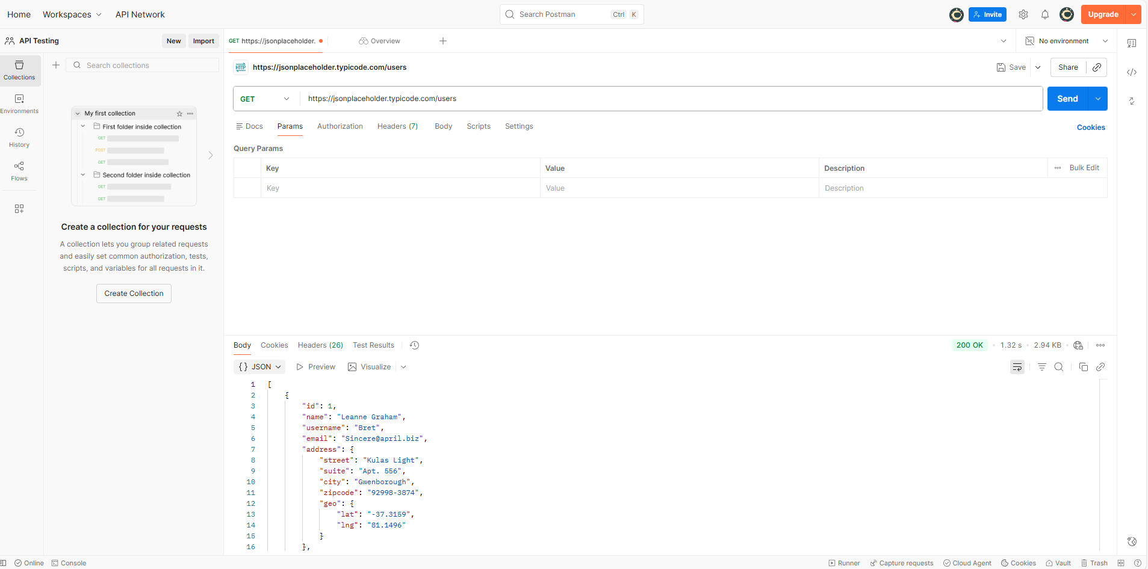
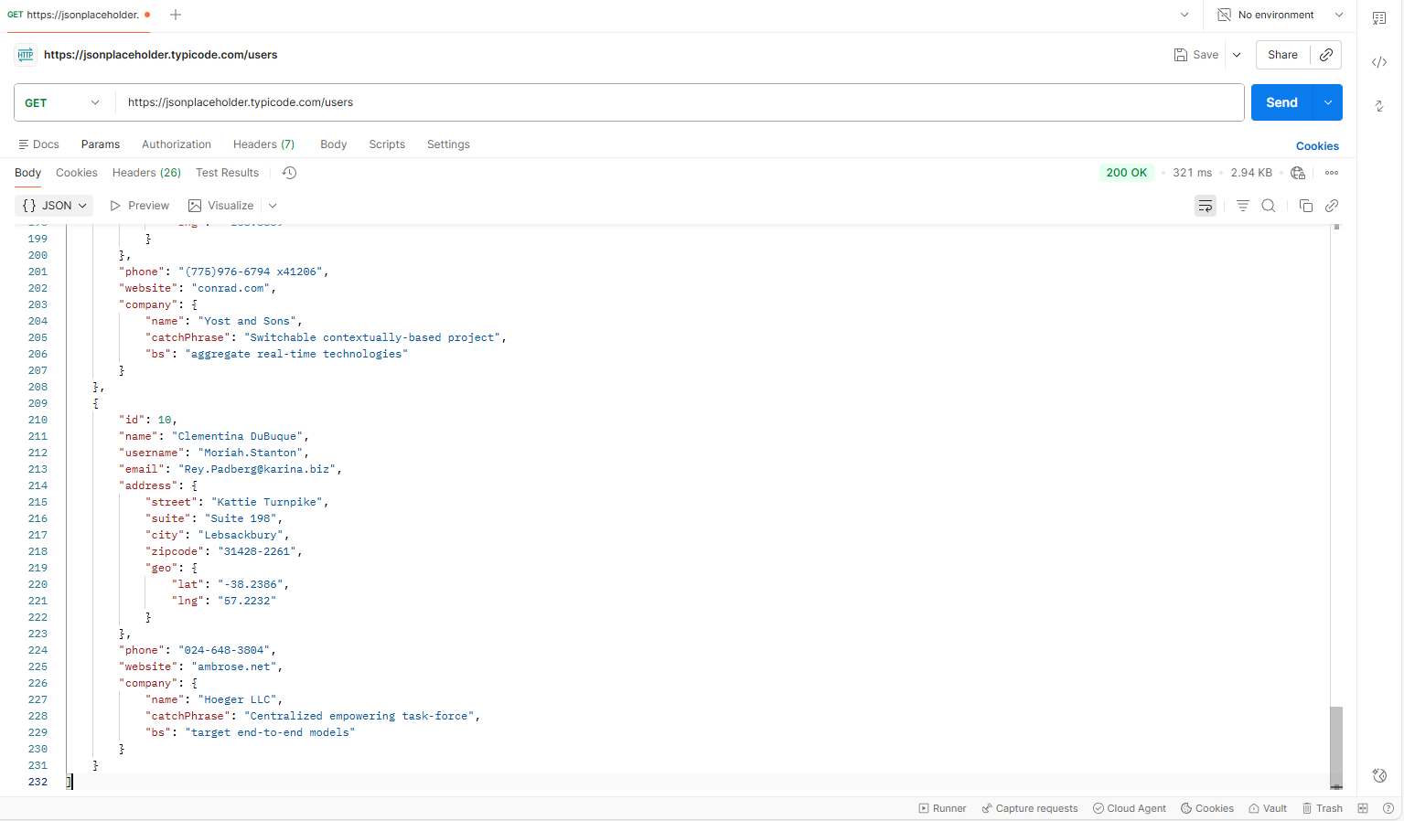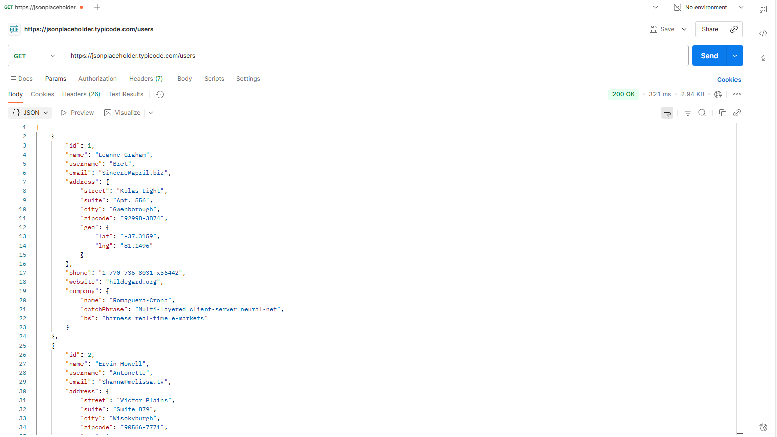

D. Short Analysis
- The API returns all users successfully.
- Data structure is consistent (array of objects).
- Response time acceptable.
- No authentication required.
E. Edge Case Test
- Edge Case : GET //users
- Expected Result: Error 404
- Actual Result: 200 OK
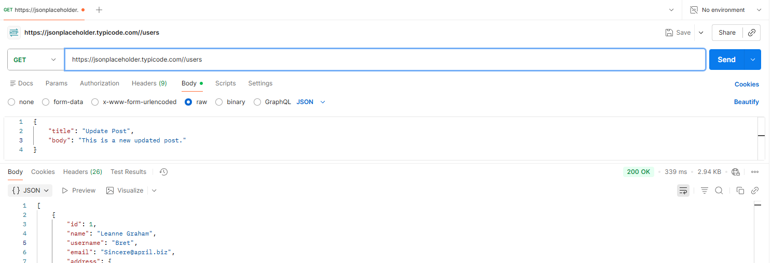

2. GET /users/1 — Retrieve a specific user

A. Request Details
- Method: GET
- URL: https://jsonplaceholder.typicode.com/users/1

B. Expected Response
- Status: 200 OK

C. Actual Result
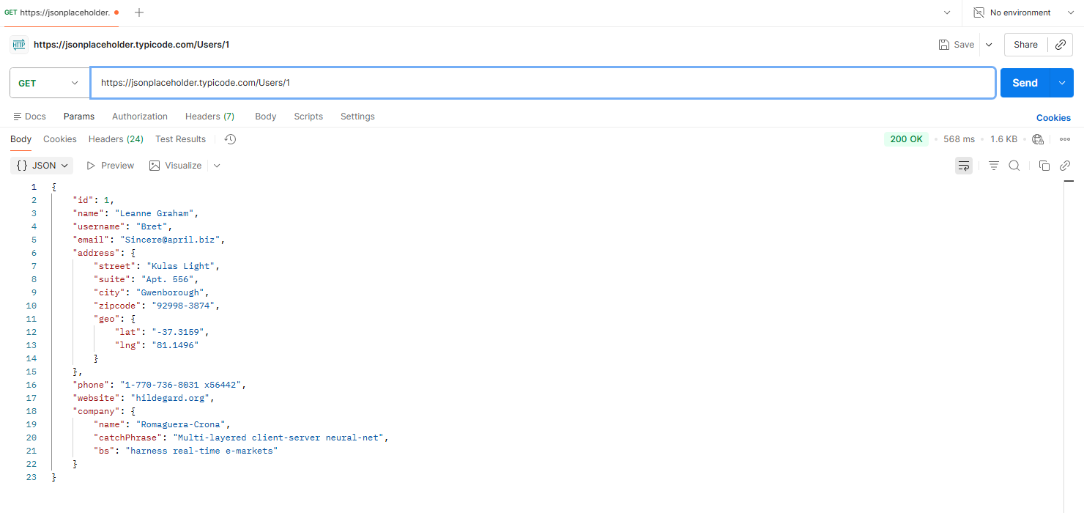

D. Analysis
- User 1 exists and returns valid data.
- Response fields follow the correct schema.
- No authorization required.
E. Edge Case Test
- Edge Case : GET //users/1
- Expected Result: Error 404
- Actual Result: 200 OK

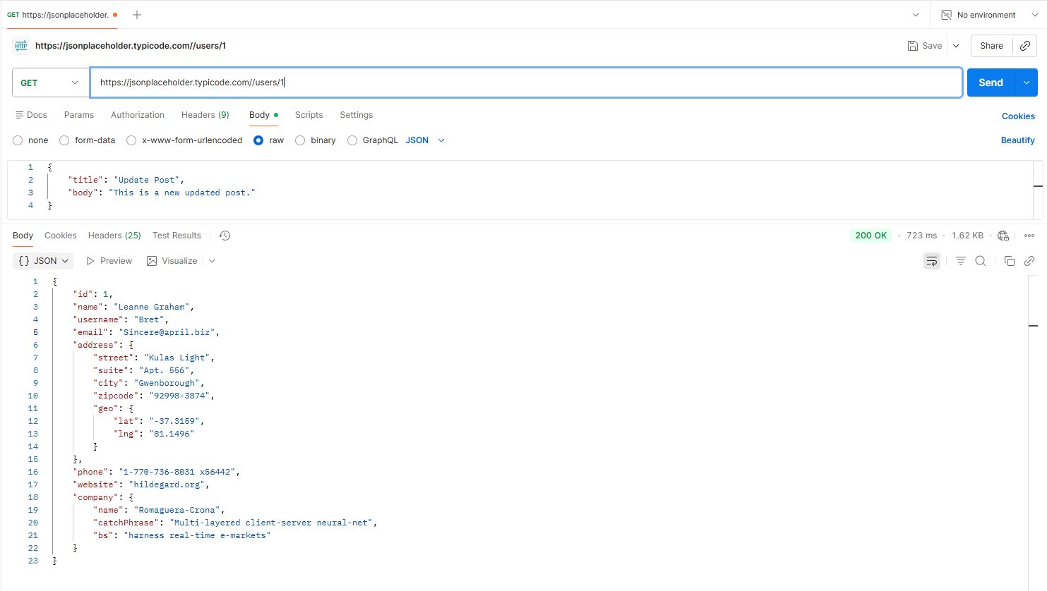

3. POST /posts — Create a new post

A. Request Details
- Method: POST
- URL: https://jsonplaceholder.typicode.com/posts
- Headers: Content-Type: application/json
- Body:
{
"title": "Sample Post",
"body": "This is a new post",
}

B. Expected Response
- Status Code: 201 Created
- Body Example:
{
"title": “Sample Post",
"body": "This is a new post",
"id": 101
}

C. Actual Result
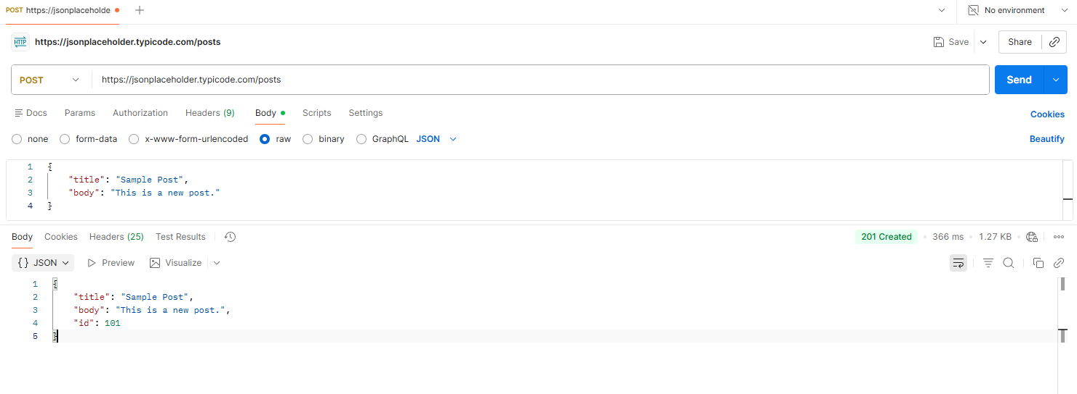
D. Analysis

- JSONPlaceholder always returns success (dummy API).
- New ID remains static (101).
- The server does not store actual data (mock only).
E. Edge Case Test
- Edge Case : inserting string for useId
- Expected Result: Error
- Actual Result: 500 Internal server error
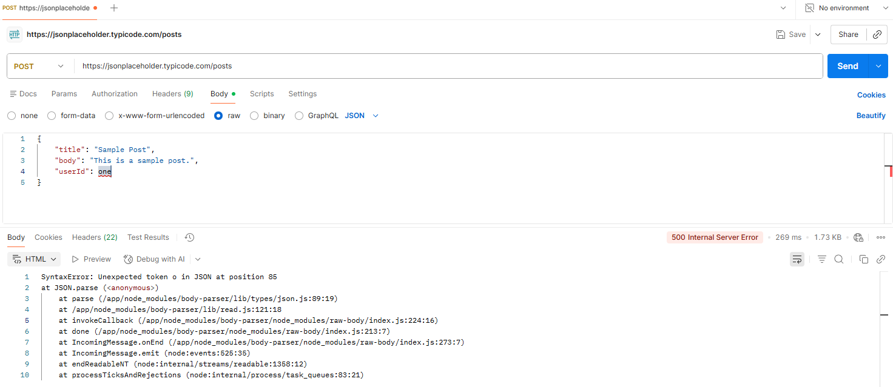

4. PUT /posts/1 — Update an existing post

A. Request Details
- Method: PUT
- URL: https://jsonplaceholder.typicode.com/posts/1
- Headers: Content-Type: application/json
- Body:
{
"id": 1,
"title": "Updated Title",
"body": "Updated Body",
"userId": 1
}

B. Expected Response
- Status Code: 200 OK
- Body Example:
{
"id": 1,
"title": "Updated Title",
"body": "Updated Body",
"userId": 1
}

C. Actual Result
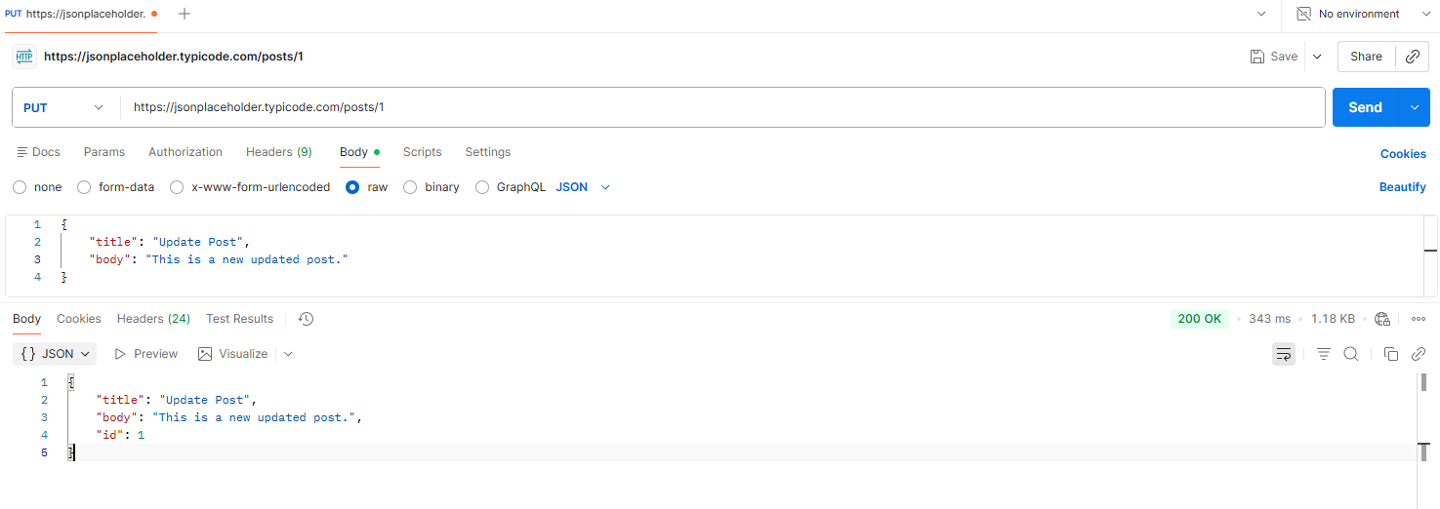

D. Analysis
- JSONPlaceholder simulates update but does NOT save it.
- Response always returns the sent body.
- Good for testing request formatting only.
E. Edge Case Test
- Edge Case : insertion wrong data type under body
- Expected Result: Error
- Actual Result: 200 ok
